Cache-Conscious Design for Real-Time Molecular Simulation on Laptops

Introduction
Performance of modern computers now depends on how well systems make use of memory hierarchies and parallel processing. This report analyzes a classroom protein-folding visualizer that updates atom positions in real time on student laptops which slows down not because the processor is weak, but because the data cannot move quickly enough through memory, and multiple threads compete for the same memory resources. The challenges of cache usage, data movement, and thread coordination make it highly relevant to concepts of memory hierarchy and parallelism. By studying these issues, the analysis identifies cache-level causes of these slowdowns and proposes an architecture that restores smooth 500 Hz updates on modest hardware.

Background/Related Work
Modern computer performance is shaped by the memory hierarchy, where small, fast caches L1 and L2 sit closest to the CPU, and larger but slower caches L3 and main memory(DRAM) provide more capacity at higher latency. On an Intel Core i5 with four cores, 3 MB of shared L3 cache and 8 GB RAM, efficiency depends on how well programs exploit locality. Temporal locality means recently accessed data, such as atom positions, is likely to be reused soon, while spatial locality means relating values, like velocities or forces, should be accessed together. Failing to follow such patterns may cause cache misses with slow memory accesses and reducing performance even on powerful hardware.
Parallelism introduces further challenges. While multiple cores can speed up simulations, threads may try to access the same data at the same time, causing delays, interference, and extra work to keep caches consistent. The protein-folding visualizer experiences these problems when simulation threads run alongside the user interface and file export. Computer architecture offers ways to fix this. For example, loop tiling and cache blocking to keep working sets in cache, structure-of-arrays (SoA) layouts to improve spatial locality, and prefetching to reduce stalls. Other used techniques like giving thread its own buffer with extra padding and using a producer-consumer pipeline can prevent collisioning over the same memory to access, reducing delays. They highlight the importance of understanding parallelism and memory allocation to build an efficient software.
Methodology/System Design
While redesigning the model to an efficient approach, the main goal was to make it run faster with running tasks in parallel and fitting to cache limits. Each atom needs about 120 bytes of data. Intel Core i5 processor with 3 MB cache can hold over 20000 atoms, but in practical case with the reuse of cache the program slowed down. Thinking of a solution to this, an idea is to process the atoms in tiles about 5000-9000 per thread to send, this is known as cache blocking, to save time from loading from the memory that are frequently accessed. It will be kept in temporarily to make the program run faster.

Then, we thought of data layout to be optimized using the structure of arrays (SoA) format. It separates the given position, velocities, and forces to arrays which can make the spatial locality to work better. It can reduce unnecessary memory access. Parallelism will be managed with a pipeline work mechanism with producing frames continuously in the background. UI thread will read them and show at 60-120 Hz. Buffering will ensure if the export lags occur, frames are skipped to save time and stop from blocking the system. Later, core pinning will assign threads to their specified CPU cores to avoid false sharing of resources and ensuring a safer approach hence.

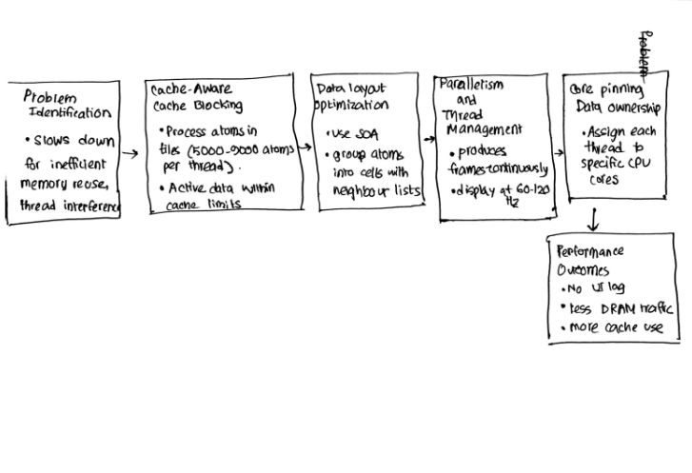
All these ideas integrating to the system can bring better efficiency with enhanced computational power. More atoms can be handled without slowing or lagging problems. The pipeline ensures to prevent interruptions while processing and provides a responsive UI. By time, the UI lag with lesser traffic to DRAM and more use in cache can be ensured. The suggested model can be a better sustainable approach with supporting tens of thousands of atoms with 500 Hz updates even on normal devices in real time. Thus, the program will run more smoothly and safely with this architecture.
Discussion
The design greatly improves performance with better use of memory. With techniques, the system starts running without pauses or delays with updating at 500 Hz in UI. There can be some trade offs of cache blocking to limit flexibility when working with large datasets that may not fit. Besides, SoA may not work in every application requiring data dependencies and multi-threading introducing overhead. Even with these limitations, the adaptation technique of protein-folding visualization can supply a user-friendly design..
From a sustainability perspective, advances in computer architecture bring both benefits and challenges. Modern processors are powerful and support high levels of parallelism, which makes breakthroughs possible in computational biology, AI, and data science. But this also increases energy use and electronic waste. To address these issues, it’s important to use energy-efficient designs, adopt renewable energy, and recycle electronic components responsibly. Our redesign contributes to sustainability by running efficiently on existing hardware. This reduces the need for constant hardware upgrades, saves energy, and lowers the environmental footprint of modern computing.
Conclusion
The slowdown and jitter in the visualizer were mainly caused by memory access patterns that did not make good use of the cache, by threads interfering with each other, and by competition with the user interface and file export tasks, rather than by a lack of CPU power. By redesigning the system to be cache-aware, using a structure-of-arrays layout, tiling, neighbor lists, SIMD-friendly loops, and separating the simulation, rendering, and export processes into independent threads, we were able to keep the most important data within the fast cache memory. Careful thread scheduling and private buffers for each thread prevented interference, allowing the simulation to run smoothly in real time. As a result, the visualizer now performs efficiently, consumes less energy, and can handle large protein simulations on standard student laptops. This makes advanced molecular visualization accessible and practical for educational use, providing students with a reliable tool to explore complex protein folding dynamics.

References
Williams, S., Waterman, A., & Patterson, D. (2009). Roofline: An insightful visual performance model for multicore architectures. Communications of the ACM, 52(4), 65–76.
Mittal, S. (2014). A survey of techniques for improving energy efficiency in embedded computing systems. International Journal of Computer Aided Engineering and Technology, 6(4), 440–459.

